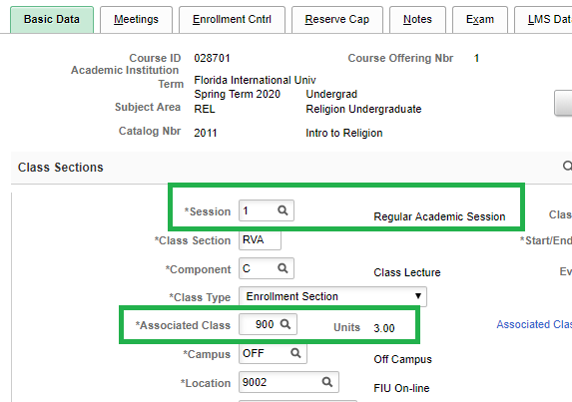

Associated Class Numbers

* Online Classes
  + 900 – Fully Online Classes in Sessions C /Regular (e.g. 1, 12W)
    - Allows fully online students to enroll in the section
  + 400 - Fully Online Classes in Sessions A (e.g. 7W1, 6W1)
    - Allows online students to enroll in sequential courses in the same semester
  + 420- Fully Online Classes in Sessions B (e.g. 7W2, 6W2)
    - Allows online & face to face students to enroll in sequential courses in the same semester
* On-Campus Classes
  + 1 – Face to Face Classes in Sessions C /Regular (e.g. 1, 12W)
    - Blocks fully online students from enrolling in the section
  + 300 – Face to Face Classes in Session A (e.g. 7W1, 6W1)
    - Allows face to face students to enroll in sequential courses in the same semester
  + 320 – Face to Face Classes in Session B (e.g. 7W2, 6W2)
    - Allows face to face students to enroll in sequential courses in the same semester
* Session Codes and Description:
  + Session A: 7W1 (Fall/Spring A) and 6W1 (Summer A)
  + Session B: 7W2 (Fall/Spring B) and 6W2 (Summer B)
  + Session C: 1 (Regular) and 12W (Summer C)