How to check Course Pre-Req and/or Co-Req

Always check if a class has Co-Requisites before enabling Waitlist each semester.
If a course has a co-req listed, DO NOT enable Waitlist.
Why? The waitlist function does not work effectively for students who are using a co-req to register for a course.
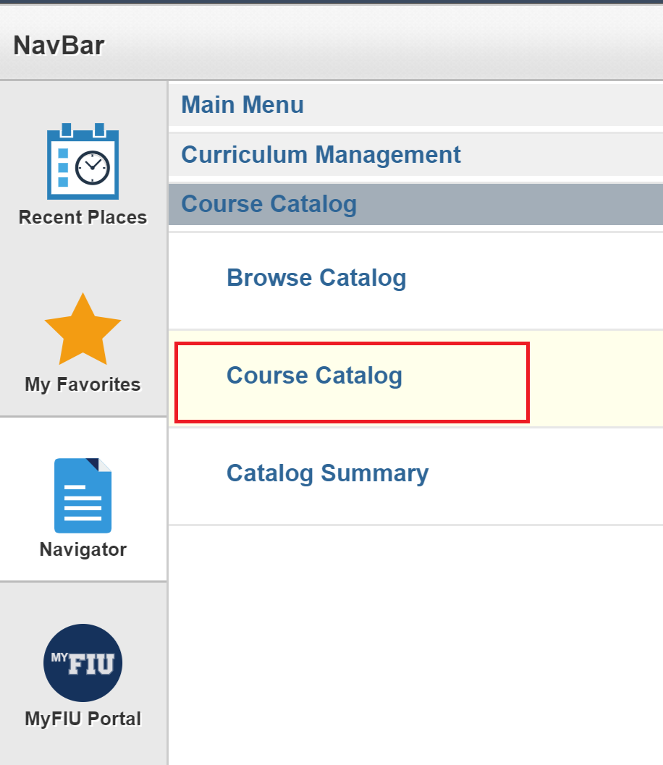

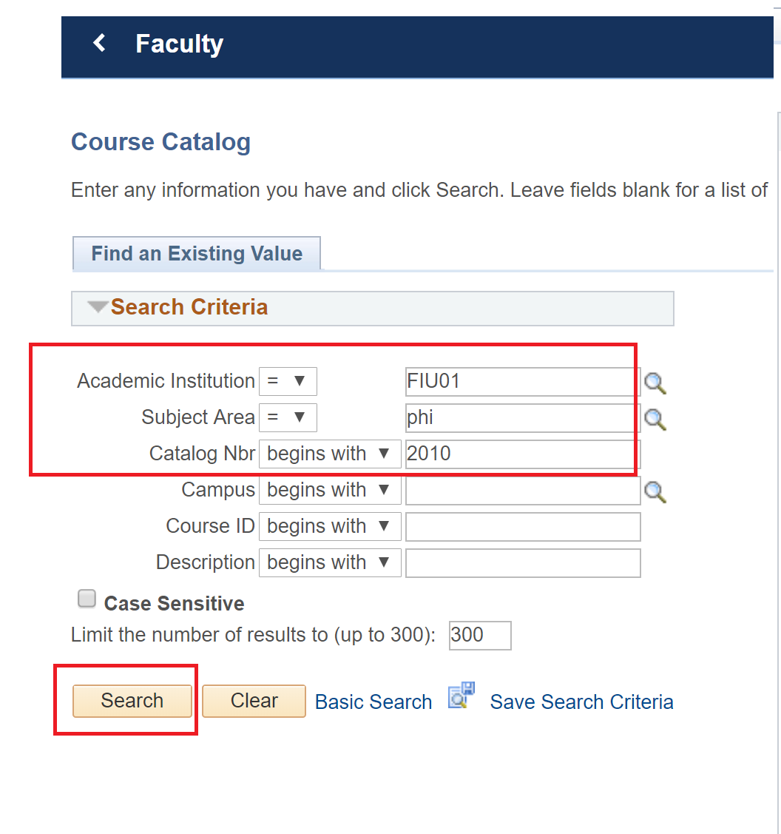
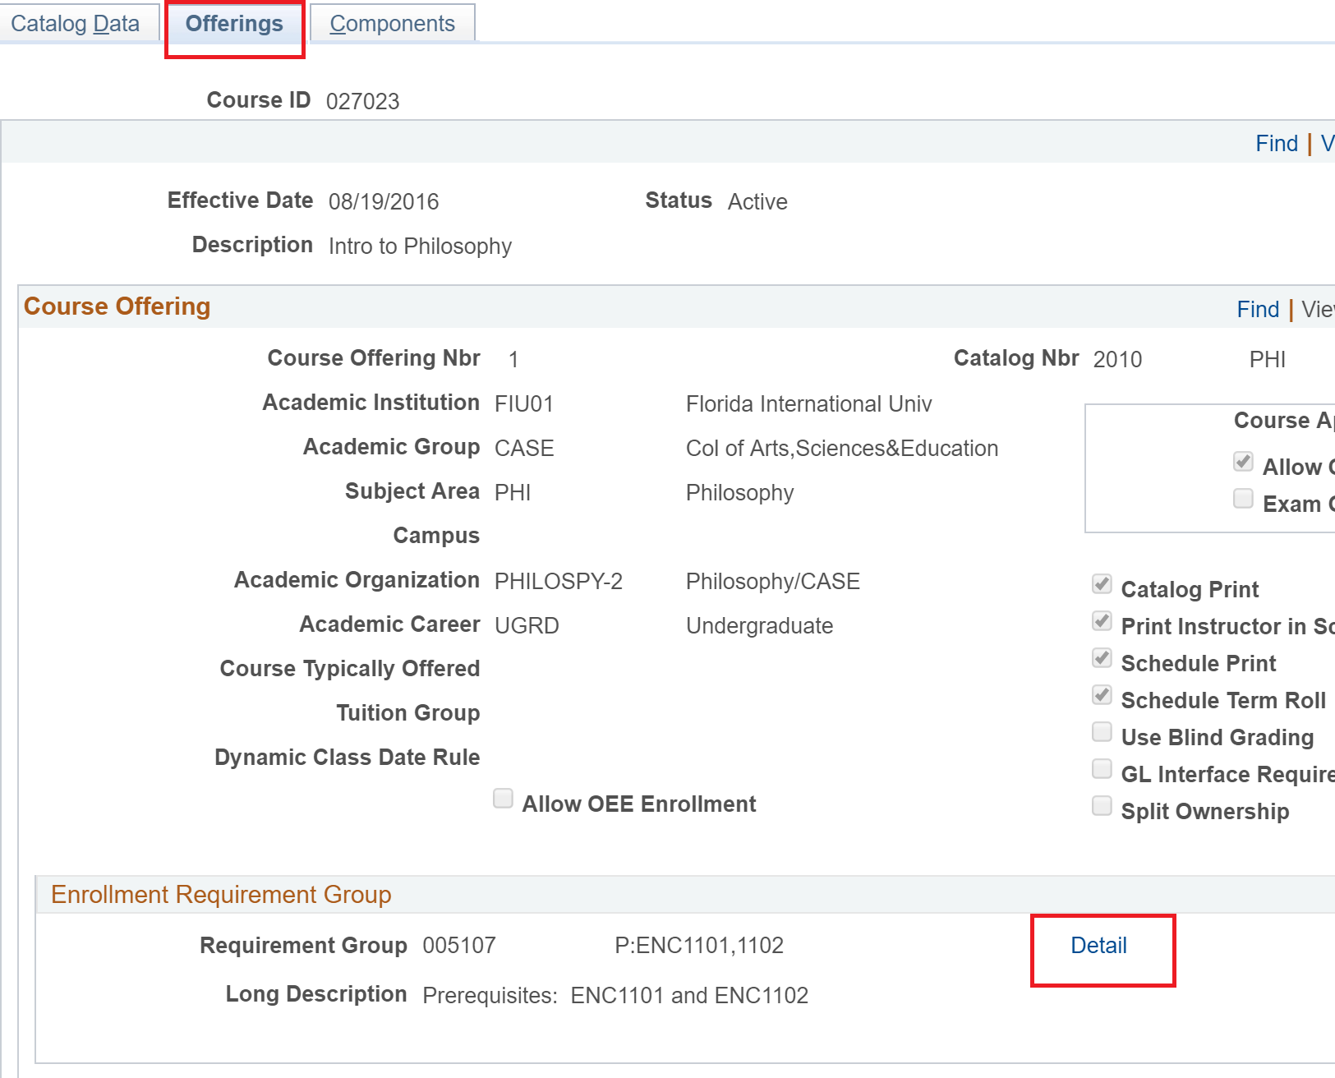
***If Blank under Enrollment Requirement Group – then the course is fine to have Waitlist Enabled.

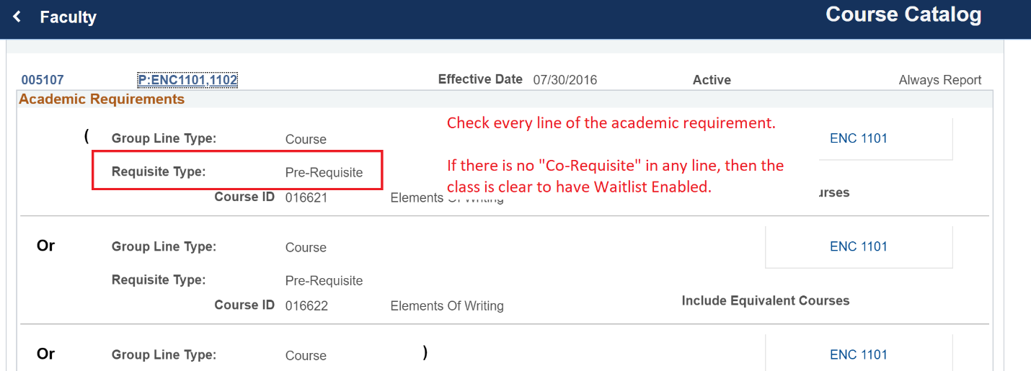

Then send following disclaimers:
Waitlist Disclaimers
(1) No override permissions to enroll in a closed class for these sections (overrides for pre-req/career/consent permissions are fine) until ADD/DROP week.
(2) Waitlist cannot be turned off once there are students on the waitlist.
(3) There is no waitlist during ADD/DROP week. The last day that Waitlist remains active is on the Friday before ADD/DROP week.
- The Registrar’s Office runs an automatic process to purge all students from all waitlists by end of business day on the Friday before classes start.
(4) Try not to put Waitlist on ALL sections of a course. Why? Because then you will not be able to accommodate any urgent overrides for a student who may need a seat in the course to graduate in that term.
- By Waitlisting ALL sections of a course you would have to defer issuing an override permission date to the beginning of ADD/DROP week
- Panthersoft does not have the ability to set a START DATE on override permissions, so you would have to remember to issue the Closed Class Permission during ADD/DROP Week).

Enabling Waitlist on PantherSoft:

