Class Permissions Navigation in Campus Solutions
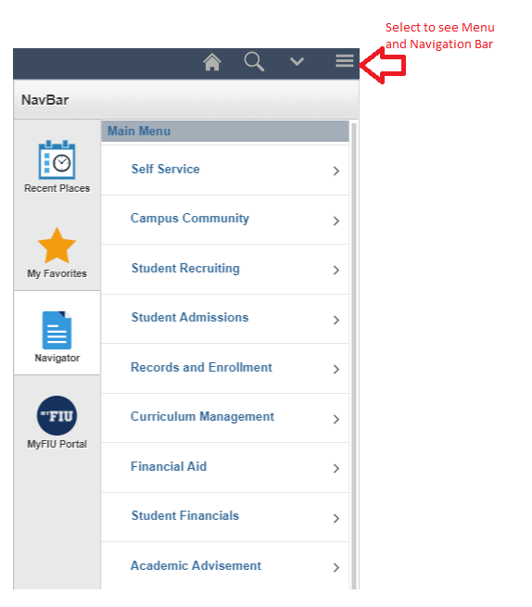

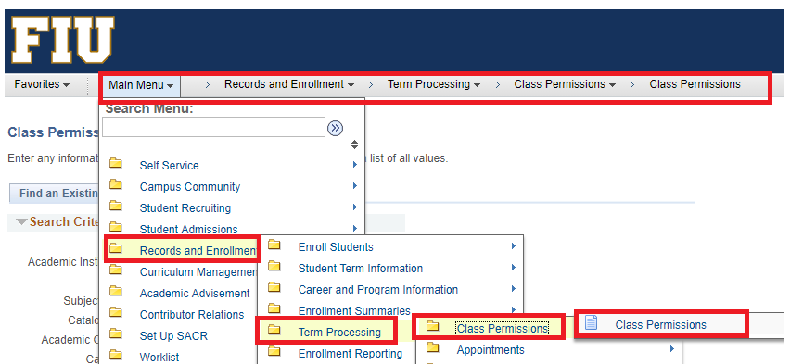
New Look in Panthersoft Fluid Upgrade

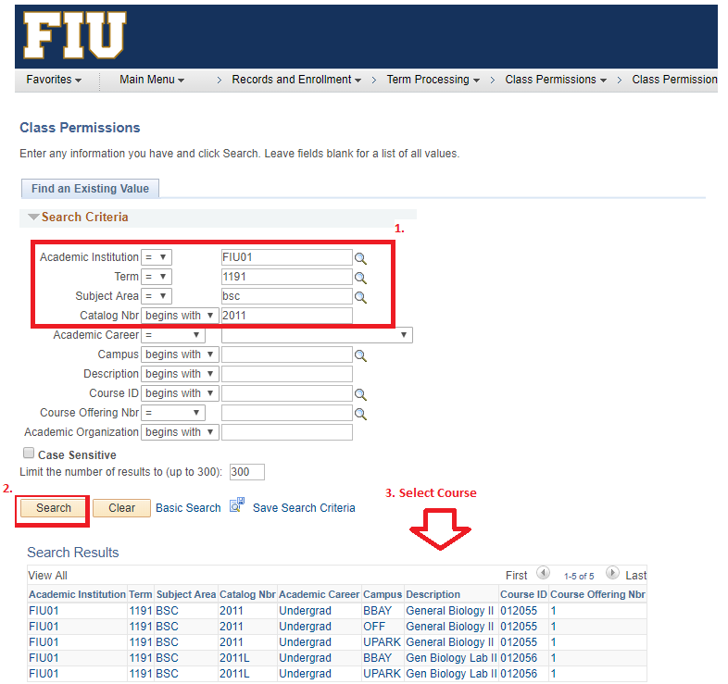
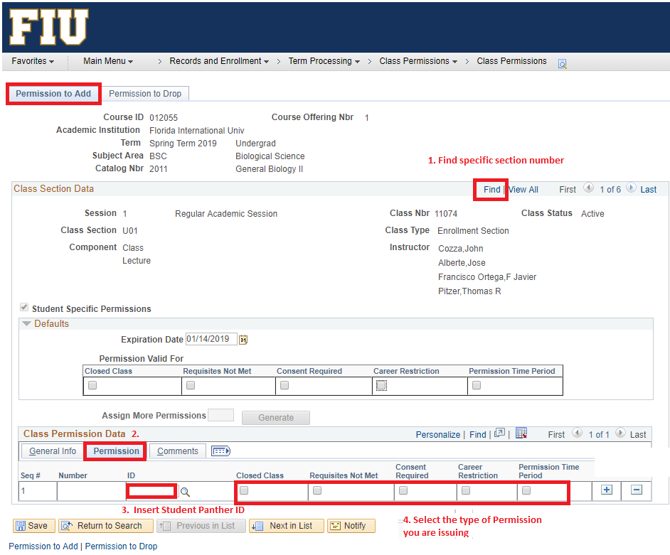
Permission Types
Closed Class – Permission to override a Full Class.
This permission should only be issued when the capacity of the classroom has been verified and another seat is really available. You must check Maintain Schedule of Classes>Meeting Tab>Facility ID Capacity to ensure the classroom has sufficient seats available to exceed the current enrollment total.
Requisites Not Met – Permission to override a co-req or pre-req requirement
Consent Required – Permission to enroll in a class with Instructor and/or Department Consent
Career Restriction – Permission to allow an Undergraduate student to enroll in a Graduate course or vice versa.
Permission Time Period – Select to allow students to enroll in a class during the enroll with permission time period. This time period is determined by a user's enrollment security access ID and by the time period end dates that are defined in the Session Time Period table.

Frequently Asked Questions
Why is the plus sign not available in the Permissions screen?
The number of available seats has been reached. In other words, the permits given out (if any) + the enrollment total are equal to the Requested Room Capacity.
How to resolve:
For Online Class Sections:
Is it an online class? Yes.
Are you issuing a Closed Class Permission and the Instructor has approved it? Yes.
Navigate to Requested Room Capacity under Maintain Schedule of Classes>Enrollment Cntrl Tab
Change the Requested Room Capacity to a higher number
Return to Class Permissions Page; you will now be able to generate more permissions for this section.
For any on-campus class section:
Is it an on-campus class? Yes.
Are you issuing a Closed Class Permission and the Instructor has approved it? Yes.
Is there enough seats in the classroom for you to issue a Closed Class Permission? Check by navigating to Maintain Schedule of Classes>Meetings Tab. Check the Facility ID field; the room capacity is next to it.
Change the Requested Room Capacity to the Room Capacity
Return to Class Permissions Page; you will now be able to generate more permissions for this section.

What if I don’t want to issue a closed class permission for a class section, and I just want to issue a pre-req override for a student who will wait to see if a seat opens up in the class section, how do I generate more permits?
Navigate to Maintain Schedule of Classes> Enrollment Cntrl Tab and increase the Requested Room Capacity field to a higher number. Never issue a Closed Class Permission for a class that has an enrollment total equal to the classroom capacity.

I have no place to insert a panther id on the Permissions Page. What should I do?
This usually means that the class is not set up for Student Specific Permissions. You will have to edit the Student Specific Permissions Checkbox under Maintain Schedule of Classes>Basic Data tab.

