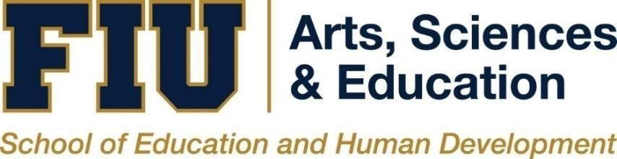

Department of Counseling, Recreation, and School Psychology

Counselor Education Student Handbook

Effective Fall 2023

Table of Contents
WELCOME 2
Counselor Education Faculty 3
Core Faculty 4
Adjunct Faculty 4
About the University 5
History 5
Campuses 5
Tuition and Fees 5
Financial Aid 6
Counselor Education Program Curricula Descriptions 6
Clinical Mental Health Counseling 7
Overview & Mission Statement 7
Minimum Degree Requirements 7
Graduation Requirements 8
School Counseling 8
Overview & Mission Statement 8
Minimum Degree Requirements 8
Applicants with Out of Field Majors 9
Graduation Requirements 10
Rehabilitation Counseling Program 10
Overview & Mission Statement 10
Minimum Degree Requirements 11
Graduation Requirements 12
Master’s Comprehensive Examination Policies 12
Clinical Mental Health Counseling 12
Purpose 12
Format & Description 12
Cost of the CPCE 13
Administration of CPCE 13
Criterion for Passing 13
Remediation Procedures 14
Appeals Procedure for Failing CPCE 2 times 14
Rehabilitation Counseling 14
Test Accommodations Request 15
Fees 15
CRCE Exam Preparation 15
Remediation Procedures 15
Appeals Procedure for Failing Exit Exam 3 times 16
School Counseling 16
Clinical Field Experiences 16
Mental Health Counseling 16
Placement Deadlines & Procedures 17
School Counseling 17
Placement Deadlines & Procedures 17
Rehabilitation Counseling 17
Placement Deadlines & Procedures 18
Activities Appropriate for Students 18
Systematic Program Evaluation 18
University Information & Policies 19
Respect for Cultural & Individual Diversity 19
Disability Services 19
Graduate Transfer of Credit 19
Time to Degree Policy 21
Annual Review of Student Progress 21
Advisement 21
Endorsement Policy 21
Academic Appeals/Student Grievance Procedures 23
Application for Graduation 23
Professional Organizations 23
National 23
State/Local 24
Counselor Education Program Course Descriptions 25
Appendices 27
Appendix A: Annual Student Evaluation Form 27
Appendix B: Accreditation & Training Standards 31
Counselor Education Student Handbook Acknowledgement 32

WELCOME

The faculty, administration, and staff of the Department of Counseling, Recreation, and School Psychology welcome you to the College of Arts, Sciences, & Education, and Florida International University. We hope your academic and professional experiences with us are positive and fulfilling as you embark on your chosen career as a professional counselor and begin one of our Counselor Education Programs. This Student Handbook provides information regarding program curricula, faculty, performance outcomes, program and university policies, professional associations, and student services.

We look forward to seeing you in classes and getting to know you better. Should you need further information, please feel free to contact any of us.

Sincerely,
Counselor Education Program Faculty

Program Address

Counselor Education Program at Florida International University CASE - CRSP
Department of Counseling, Recreation, and School Psychology
11200 SW 8th Street, Miami, FL 33199
+1 305-348-3418
http://counselored.fiu.edu/

Counselor Education Faculty

Core Faculty
Valerie E. Dixon, Ph.D., CRC, LMHC (QS), PVE
Program Director
Clinical Associate Professor
Rehabilitation Counseling Track Coordinator, SARCA Advisor
305-348-3865, verussel@fiu.edu
Research/Professional Interests: Counseling interventions for underrepresented populations (offenders, persons w/disabilities, minorities); counseling supervision and staff development/training for counseling practitioners

Tameeka Hunter, Ph.D., LPC, NCC, CRC
Assistant Professor
tahunter@fiu.edu
Research interests: Resilience of marginalized and multiply marginalized populations, including people living with disabilities and chronic illnesses, people of color, sexual- and gender-expansive people, and women; The impact of resilience and strength-based approaches on marginalized and multiply marginalized populations' psychosocial, educational, and vocational functioning.

Zachary Pietrantoni, Ph.D., NCC, LSC
Assistant Professor
School Counseling Track Coordinator, CSI Chapter Faculty Advisor
305-348-7473, zpietran@fiu.edu
Research Interests: School counselor development, child maltreatment prevention, interdisciplinary collaboration, and social justice and human rights education.

Alena Prikhidko, Ph.D., LMFT
Assistant Professor
Clinical Coordinator
305-348-6340, aprikhid@fiu.edu
Research/Professional Interests: Emotion regulation, counselors’ professional development, intensive parenting, and violence prevention.

Michelle Bradham-Cousar, Ph.D., CRC, CVE, LMHC, NCC
Assistant Clinical Professor
Michelle.BradhamCousar@fiu.edu
Research Interests: Artificial Intelligence, Technology, STEM (Science, Technology, Engineering and Math), Virtual Reality, Armed Forces/Military, Rehabilitation Engineering, Entrepreneurial Cognitive learning, Individuals with Disabilities in Public Education, Disaster, Crisis, Trauma, Vocational Assessment, Career, Forensic, Legal and Medical.

Christina McGrath Fair, Ph.D., LMHC
Visiting Clinical Assistant Professor
CSI Chapter Faculty Advisor, Clinical Mental Health Counseling Coordinator, Exit Exam Coordinator, Continuing Education Coordinator
cmcgrath@fiu.edu
Research Interests: LGBTQ+/Gender Issues, sexual culture, social justice, and clinical supervision.

Adjunct Faculty
Alison Davis, Ph.D., aldavis@fiu.edu
Carmen Larson, Ph.D., clarson@fiu.edu
Christopher Cheung, Ph.D., ccheung@fiu.edu
Porshia Cunningham, Ph.D., pocunnin@fiu.edu
Krisdhal Ugarte-Torre, Ph.D., kugar001@fiu.edu

About the University

Florida International University is one of America's most dynamic young universities. Since opening in 1972, FIU has achieved many benchmarks of excellence that have taken other universities more than a century to reach. The University has a nationally renowned full-time faculty, known for their outstanding teaching and innovative research; students from throughout the U.S. and more than 130 foreign countries; and its alumni have risen to prominence in every field and are a testament to the University's academic excellence.
A member of the State University System of Florida, FIU is a research university offering a diverse selection of undergraduate, graduate and professional programs. Through its 21 colleges and schools, FIU offers more than 200 baccalaureate, master's, and doctoral degree programs in more than 280 majors, conducts basic and applied research, and provides public service. Committed to both quality and access, FIU meets the educational needs of traditional students as well as the increasing number of part- time students and lifelong learners. Interdisciplinary centers and institutes at the University conduct research and teaching that address economic and social concerns.
FIU currently has about 50,000 students, about 1100 faculty and over 200,000 alumni, making it the largest public university in South Florida. FIU has been ranked among the top 100 public national universities in the U.S. News & World Report annual guide to "America's Best Colleges." FIU was the youngest institution in the group. The magazine has reported that FIU students are among the least indebted college students in the nation and recognized the University as a "best buy" in higher education. In 1998, Kiplinger's Personal Finance Magazine ranked FIU as the country's 18th best value in public higher education. FIU was named one of the top 10 public commuter colleges in the U.S. in the 1995 edition of Money Guide, an annual report published by Money Magazine, and has been cited in several other of the country's leading college guides. FIU is a member of Phi Beta Kappa, the country's oldest and most distinguished academic honor society.

History
FIU was established by the Florida legislature in 1965. Classes began in September 1972, with 5,667 students enrolled in upper-division and graduate programs, the largest opening day enrollment in the history of American higher education. In 1981, the University added lower-division classes for freshmen and sophomores, expanding its enrollment capacity. In 1984, the University received authority to begin offering degree programs at the doctoral level; these programs received Level IV accreditation from the Southern Association of Colleges and Schools (SACS) in 1986. In 2000, the Carnegie Foundation for the Advancement of Teaching reclassified FIU as a Research Extensive University. The institutions in the Research Extensive University category offer a full range of baccalaureate programs, graduate education through the doctoral level (and confer doctorates in more than five disciplines) and are committed to research.

Campuses
FIU has two major campuses, Modesto Maidique (MMC) in western Miami-Dade County and the North Campus (BBC) on Biscayne Bay in northeast Miami-Dade County, and an academic site that serves Broward County, in Miramar (FIU at I-75 in Miramar). Most courses in the Counselor Education Program are typically offered at the MMC campus.

Tuition and Fees
Please refer to the FIU Tuition & Fees for the latest information about current tuition and other related university fees.
The Counselor Education Program also requires students to purchase and create a Tevera account for field documentation and timekeeping of clinical experiences. An account with lifetime access is ~$200 (This fee is subject to change).
Students are responsible for purchasing their comprehensive examinations. Clinical Mental Health Counseling students are charged $150 for the Counselor Preparation Comprehensive Examination (CPCE). Rehabilitation Counseling students are charged $385 for the Certified Rehabilitation Counseling Examination (CRCE). More information can be found under the Master’s Comprehensive Examination Policies on page 17. (These fees are subject to change).

Financial Aid
Financial aid is in the form of grants, scholarships, assistantships, fellowships, loans and work-study. These are awarded based on academic achievement and/or financial need. Students are encouraged to view the Financial Aid website. There are a limited number of scholarships and assistantships available in the Department and in other divisions in the School of Education and Human Development. Anyone interested in a graduate assistantship should review the website for further information.
Please refer to Financial Aid website for the latest information about financial aid and related sources of funding.
Fully admitted graduate students are eligible to apply for a School of Education and Human Development Graduate Assistantship. For more information about applying, requirements, benefits, and responsibilities please refer to the Graduate Assistantship website.

Counselor Education Program Curricula Descriptions

The Counselor Education Program offers the Master of Science in Counselor Education with three specialization tracks. These include Clinical Mental Health Counseling, School Counseling, and Rehabilitation Counseling.

We offer three 60-credit programs (42 credits in-person, and 18 online or hybrid). The tracks follow a competency-based model, the early part of which is largely generic in nature. It is concerned with the development of knowledge and skills in the areas of individual and group counseling, consultation, preventive mental health, educational-vocational development, client appraisal systems intervention, and model program organization and evaluation. The latter part of the program is more differentiated and enables specialization in Clinical Mental Health, School, or Rehabilitation Counseling.

Students should be advised that a substantial amount of time must be spent in fieldwork to meet practicum and internship requirements. Students should plan for this fieldwork to be during the day Monday through Friday, rather than during the evening or weekend. (This is especially important for students who wish to be certified in school counseling). Program completion is not compatible with full-time employment. Although most of the courses are offered in the evening on campus or online, the fieldwork experiences are most commonly completed during daytime hours. Fieldwork must also be completed in either Broward or Miami-Dade County.

PROGRAM OBJECTIVES

The objectives of the Counselor Education program at Florida International University are:
- To prepare competent and ethical mental health and school counselors, who:
- Understand, master, and apply subject matter from the following areas:
- Professional Counseling Orientation and Ethical Practice
- Multicultural and counseling diverse populations (i.e., ethnic, racial, cultural, gender, sexual/affectional, class, age, disability, and/or spiritual/religious)
- Counseling and helping relationships
- Personality and counseling theories and practice
- Human development theories
- Group theories and practice
- Assessment and Testing
- Research and program evaluation
- Career and vocational counseling
- To increase the number of students enrolled in the program.
- To increase the number of students that complete the program.
- To ensure students will be satisfied with their overall graduate program experience.

Clinical Mental Health Counseling

Overview & Mission Statement
The Master of Science in Counselor Education, Clinical Mental Health Counseling Track, is nationally accredited by the Council for the Accreditation of Counseling and Related Education Programs (CACREP) and meets the curriculum requirements of the Florida Board of Social Worker, Marriage and Family Therapy, and Mental Health Counseling.

The FIU Counselor Education program and its faculty will strive to be leaders by educating and training diverse students in an urban, public, research university through excellence in teaching, transformative research, and substantial service to the university, profession, and local/global community.

Our mission is to prepare competent clinical mental health counselors to significantly impact diverse individuals in a variety of settings (e.g., hospitals, agencies, private practice). Our program trains counselors to meet the challenges involved in working in a multiethnic, multicultural, and urban environment. The second part of our mission is to provide both educational experiences that emphasize multiculturalism in practice and theory as well as opportunities for professional and personal growth.
Finally, it is our intent to produce ethical and responsible clinical mental health counselors who function to help others achieve positive personal change.

Minimum Degree Requirements
The Clinical Mental Health Counseling program requires the completion of 60 semester hours of academic work beyond the baccalaureate degree and includes four major components: Counseling Core, Mental Health Specialization, and Clinical Experience.

Counseling Core (27 credits): These courses are designed to advance the theoretical and practical application of counseling skills and techniques in the areas of individual and group counseling, as well as systems interventions. These courses include:

- EDP 6277 Human Development Across Lifespan
- MHS 5340 Educational & Vocational Counseling
- MHS 5400 Counseling Skills & Techniques
- MHS 6200 Measurement & Appraisal in Counseling
- MHS 6428 Cross-Cultural Counseling
- MHS 6511 Group Counseling
- MHS 6630 Program Evaluation & Research in Counseling
- MHS 6700 Legal, Ethical, & Professional Issues in Counseling
- MHS 6802 Personality Theories

Mental Health Specialization (21 credits): These courses are designed to provide a focus on topics most pertinent to working with clients presenting with a variety of concerns in Mental Health settings. These courses include:

- MHS 6020 Foundations of Mental Health Counseling
- MHS 6411 Counseling & Consultation in Community Settings
- MHS 6427 Adult Psychopathology
- MHS 6450 Substance Abuse Counseling
- MHS 6470 Human Sexuality Counseling
- SDS 5460 Crisis Counseling & Interventions
- SDS 6411 Counseling Children & Adolescents

Clinical Experience (12 credits): These courses occur at the end of the training program and are designed to provide students with the opportunity to practice the knowledge and skills acquired in the program. Interns will participate in activities equal to that of a regular Mental Health Counselor but with close university and site supervision. These courses include:

- MHS 6800 Advanced Practicum in Counseling & Consultation
- MHS 6820 Supervised Field Experience in Counseling

Students are also responsible for meeting academic program requirements and deadlines and are therefore, advised to meet with their faculty advisor on a regular basis. The program curricula and requirements are subject to change at any time.

Graduation Requirements
Master’s program students must maintain an overall GPA of 3.0 to graduate. Earned grades below a C in courses that are part of a master’s program of study will not be accepted toward graduation. Students must retake any program course that falls below a grade of C (i.e., a D or an F).

Students must earn a grade of “B” or higher in MHS 6800, Advanced Practicum in Counseling, and MHS 6820, Supervised Practice in Counseling (internship) to be eligible for graduation.

Students must successfully pass the Comprehensive Exam (CPCE). The student is to take this exam through Computer Based Testing on their own at any appropriate time. Qualifying scores and remediation practices are described in this handbook.

School Counseling

Overview & Mission Statement
The Master of Science in Counselor Education, School Counseling Track, is nationally accredited by the Council for the Accreditation of Counseling and Related Education Programs (CACREP) and is approved by the State of Florida Department of Education, the Florida Board of Regents.

The FIU Counselor Education program and its faculty will strive to be leaders by educating and training diverse students in an urban, public, research university through excellence in teaching, transformative research, and substantial service to the university, profession and local/global community.

Our mission is to prepare competent school counselors to significantly impact diverse individuals in a variety of settings (e.g., those at the elementary, middle, and/or high school levels). Our program trains counselors to meet the challenges involved in working in a multiethnic, multicultural, and urban environment. The second part of our mission is to provide both educational experiences that emphasize multiculturalism in practice and theory as well as opportunities for professional and personal growth.
Finally, it is our intent to produce ethical and responsible school counselors who facilitate learning, and development, and achieve positive change within urban, diverse school settings.

Minimum Degree Requirements
The School Counseling program requires the completion of 60 semester hours of academic work beyond the baccalaureate degree and includes four major components: Counseling Core, School Specialization, Professional Studies, and Clinical Experience.

Counseling Core (27 credits): These courses are designed to advance the theoretical and practical application of counseling skills and techniques in the areas of individual and group counseling, as well as systems interventions. These courses include:
- EDP 6277 Human Development Across Lifespan
- MHS 5340 Educational & Vocational Counseling
- MHS 5400 Counseling Skills & Techniques
- MHS 6200 Measurement & Appraisal in Counseling
- MHS 6428 Cross-Cultural Counseling
- MHS 6511 Group Counseling
- MHS 6630 Program Evaluation & Research in Counseling
- MHS 6700 Legal, Ethical, & Professional Issues in Counseling
- MHS 6802 Personality Theories

School Specialization (21 credits): These courses are designed to provide a focus on topics most pertinent to working with students presenting with a variety of concerns in school settings. These courses include:
- EDF 6211 Educational Psychology
- MHS 6450 Substance Abuse Counseling
- SDS 6411 Counseling Children & Adolescents
- SDS 5420 Counseling Students with Exceptionalities
- SDS 5460 Crisis Counseling & Interventions
- SPS 6199 Family, School Collaboration & Consultation
- SDS 6700 Organization & Administration of School Counseling

Clinical Experience (12 credits). These courses occur at the end of the training program and are designed to provide students with the opportunity to practice the knowledge and skills acquired in the program. Interns will participate in activities equal to that of a regular School Counselor, but with close university and site supervision. These courses include:

- SDS 6800 Advanced Practicum in Counseling & Consultation
- SDS 6820 Supervised Field Experience in Counseling

The prospective student should be advised that a substantial amount of time is spent in field work to meet practicum and internship requirements. The practicum requirement (100 hours) is the equivalent of one workday per week spent in a field placement during one academic semester. The internship (600 hours) is the equivalent of a full-time work (five days per week) experience for the period of one academic semester. The student should plan for this fieldwork to be during the day, rather than during evening hours, as the field experiences must be completed in a Public (non-charter) elementary, middle, or secondary school setting.

Students are also responsible for meeting academic program requirements and deadlines and are therefore advised to meet with their faculty advisor on a regular basis. The program curricula and requirements are subject to change at any time.

Applicants with Out of Field Majors
Students seeking admission to the School Counseling track with an “out of field major” (non-education) and/or who do not hold a Florida Teacher's Certificate are required to successfully complete co-requisite education courses at the graduate level during the counseling program (unless similar courses were taken during their undergraduate degree program). These professional education courses (covering classroom management; general methods of teaching; TESOL; and reading) are required by the Florida State Department of Education in order to meet state certification requirements. They must also pass the Florida Teacher Certification General Knowledge and Professional Education Exams. Students who plan on working in a state other than Florida are advised to check the certification requirements of that particular state. Certification is an individual, personal responsibility. Courses that satisfy these requirements include:

Classroom Management:

- EDP 5255 Classroom Management

General Methods of Teaching (choose one):

- EDG 5414*
- EDA 6061
- EDG 6250

*Taking EDF 5414 simultaneously fulfills BOTH the classroom Management & Methods of Teaching requirements

TESOL:

- TSL 5361C TESOL for Secondary Teachers

Reading:

- RED 5339 Subject Related Reading

Graduation Requirements
Master’s program students must maintain an overall GPA of 3.0 to graduate. Earned grades below a C in courses that are part of a master’s program of study will not be accepted toward graduation and must be retaken.

Students must have received a grade of “B” or higher in SDS 6800, Advanced Practicum in Counseling, and SDS 6820, Supervised Practices in Counseling (internship).

Students must successfully pass the Comprehensive Exam for their program area (school counseling students must show proof of having passed the Florida Professional Education Exam and the Subject Area Exam in School Counseling).

Students must demonstrate successful completion of the Florida Educators’ Accomplished Practices (FEAPs). Uploading all course artifacts on Portfolio demonstrating the FEAPs is required for graduation.

Rehabilitation Counseling Program

Overview & Mission Statement
The Master of Science in Counselor Education, Rehabilitation Counseling Track, is nationally accredited by the Council for Accreditation of Counseling and Related Educational Programs (CACREP) and prepares students to work with individuals with disabilities in diverse, community settings.

The Counselor Education Program is housed within the Department of Counseling, Recreation, and School Psychology in the School of Education and Human Development. The College is an urban, multicultural setting, which reflects both the student body of the program as well as the diversity of the clients who will be served by our graduates.

Our mission is to prepare competent rehabilitation counselors to fulfill the national critical shortage of diverse and trained professionals who can provide vocational and rehabilitation counseling and services to individuals with physical or mental disabilities in a variety of settings (e.g., agencies, hospitals, treatment centers, and assisted living facilities). Our program trains counselors to meet the challenges involved in working in a multiethnic, multicultural, and urban environment. The second part of our mission is to provide both educational experiences that emphasize multiculturalism in practice and theory as well as opportunities for professional and personal growth. Finally, it is our intent to produce ethical and responsible rehabilitation counselors who assist clients struggling with physical, intellectual, and emotional disabilities.

Minimum Degree Requirements
The Rehabilitation Counseling program requires the completion of 60 semester hours of academic work beyond the baccalaureate degree and includes four major components: Counseling Core, Rehabilitation Specialization, Measurement and Research, and Clinical Experience.

Counseling Core (27 credits): These courses are designed to advance the theoretical and practical application of counseling skills and techniques in the areas of individual and group counseling, as well as systems interventions. These courses include:

- EDP 6277 Human Development Across Lifespan
- MHS 5340 Educational & Vocational Counseling
- MHS 5400 Counseling Skills & Techniques
- MHS 6200 Measurement & Appraisal in Counseling
- MHS 6428 Cross Cultural Counseling
- MHS 6511 Group Counseling
- MHS 6630 Program Evaluation & Research in Counseling
- MHS 6700 Legal, Ethical, & Professional Issues in Counseling
- MHS 6802 Personality Theories

Rehabilitation Specialization (21 credits): These courses are designed to provide a focus on topics most pertinent to working with clients presenting with a variety of concerns in the areas of Rehabilitation settings. These courses include:

- MHS 6411 Advanced Counseling & Consultation in Community Settings
- MHS 6427 Adult Psychopathology
- MHS 6470 Human Sexuality Counseling
- RCS 6031 Rehabilitation Counseling: Principles & Practices
- RCS 6080 Medical Aspects of Disability
- RCS 6245 Psychological/Sociological Aspects of Disability
- RCS 6625 Service Delivery & Case Management in Rehabilitation

Clinical Experience (12 credits): These courses occur at the end of the training program and are designed to provide students with the opportunity to practice the knowledge and skills acquired in the program. Interns will participate in activities equal to that of a regular Rehabilitation Counselor but with close university and site supervision. These courses include:

- RCS 6801 Advanced Practicum in Rehabilitation Counseling
- RCS 6821 Supervised Field Experience in Rehabilitation Counseling (Internship)

Rehabilitation counselors (RCs) in the public and private sectors assist persons with disabilities in all age groups to become productive citizens and/or improve the quality of their lives. The Rehabilitation Act of 1998 mandated that RCs be nationally certified. To be eligible for certification, RCs must have completed a master’s degree in Rehabilitation Counseling or a Master’s degree in Counseling or a related area with specific coursework in rehabilitation counseling. In addition, throughout the State of Florida, as in other States, there is a shortage of certified RCs with master’s degrees. RCs provide a variety of services that include, but may not be limited to (a) individual personal adjustment counseling, (b) family counseling and consultation, (c) medical and psychological consultation and purchase of service, (d) educational and vocational career guidance and counseling services, (e) coordination of services and case management, (h) group counseling, (i) job analysis, job development, and job placement, (j) vocational assessment and disability evaluation, and (k) advocacy.

Students are also responsible for meeting academic program requirements and deadlines and are advised to meet with their faculty advisor on a regular basis. The program curricula and requirements are subject to change at any time.

Graduation Requirements
Master’s program students must maintain an overall GPA of 3.0 to graduate. No grades below a C received in courses that are part of a master’s program of study will be accepted toward graduation and must be retaken.

Students must have received a grade of “B” or higher in RCS 6801, Advanced Practicum in Counseling and RCS 6821, Supervised Practices in Counseling (internship) in order to graduate.

Students must successfully pass the Certified Rehabilitation Counselor Exam (CRCE).

Master’s Comprehensive Examination Policies

Clinical Mental Health Counseling
For Clinical Mental Health Counseling students, this comprehensive examination will be an objective test known as the Counselor Preparation Comprehensive Examination (CPCE). The following will outline the purpose, format, and logistics of the CPCE for Clinical Mental Health Students.

Purpose
The purpose of the comprehensive examination process is to help students synthesize their learning about counseling and to ensure that students have a thorough understanding of professional attitudes, skills, and knowledge related to the eight common-core areas as defined by CACREP’s Standards for Preparation. Evaluation of students’ examinations will provide the faculty an opportunity to appraise students’ academic preparation.

Format & Description
The exam is an objective test known as the Counselor Preparation Comprehensive Examination (CPCE). The CPCE was developed by the Center for Credentialing & Education (CCE), an affiliate of the National Board for Certified Counselors (NBCC). The CPCE is a knowledge-based examination that reflects the eight core curriculum areas approved by CACREP. The exam is a summative evaluation that measures pertinent and professional knowledge acquired by students during their counselor preparation programs. Currently, there are about 100 master’s programs using the CPCE.

The CPCE consists of 160 items with 20 items per CACREP area. Although there are 160 questions, only 136 are graded. The exam is administered as a whole and not in sections. The 8 core curriculum areas of the CPCE are:

Human Growth and Development – studies that provide an understanding of the nature and needs of individuals at all developmental levels.
Social and Cultural Foundations – studies that provide an understanding of issues and trends in a multicultural and diverse society.
Helping Relationships – studies that provide an understanding of counseling and consultation processes.
Group Work – studies that provide an understanding of group development, dynamics, counseling theories, group counseling methods and skills, and other group work approaches.
Career and Lifestyle Development - studies that provide an understanding of career development and related life factors.
Appraisal – studies that provide an understanding of individual and group approaches to assessment and evaluation.
Research and Program Evaluation - studies that provide an understanding of types of research methods, basic statistics, and ethical and legal considerations in research.
Professional Orientation and Ethics – studies that provide an understanding of all aspects of professional functioning including history, roles, organizational structures, ethics, standards, and credentialing.

Detailed descriptions of the core areas are found at https://www.cacrep.org/.

Students with disabilities that need accommodations should consult with their advisors to obtain assistance in arranging individual examination requirements.

Cost of the CPCE
Each student is charged $150.00 for the CPCE. This fee will be paid directly to CCE during the student online exam registration process. (This fee is subject to change by the NBCC).

Administration of CPCE
Students are provided authorization to take the CPCE exam once they are registered for practicum courses. The updated testing administration process includes students registering with CCE: Go to the CPCE registration link and fill out the required information, complete this registration at least 7 business days (not calendar) before testing to allow sufficient processing time.
Once students complete the registration, they will receive an “Authorization to Test” email from Pearson within 7 business days.

Students can test up to 2 times within the 6-month eligibility period if their eligibility will not expire before the test date. Students have a waiting period of at least 30 days after the first test administration before a second administration can occur. Eligibility period extensions can be granted by the exit exam coordinator on a case-by-case basis. Upon completion of testing, student will receive scores immediately. Please submit those scores to the Counselor Education Program Exit Exam Coordinator. A result (pass/fail) response will be provided as soon as national statistics from CCE are received. Official results will be provided as soon as possible so students can have time to retake exam if needed. Those that do not pass the exam in three administration attempts will need to follow the exit exam remediation policy.

Criterion for Passing
Exams will be completed and submitted electronically. Each exam score will consist of a score for each section, as well as a total score. The results of each exam will then be electronically reported to the program faculty. Any questions about this process may be directed to the current CPCE coordinator.

A passing grade is determined for each administration of the exam. The FIU faculty have designated a passing score to be at one standard deviation below the national mean for that test administration. Only students’ total score will be considered to determine a passing or failing grade. Those who do not pass the exam in two administration attempts will need to follow the exit exam remediation policy.

Remediation Procedures
Students who do not pass the exam the first time will be able to re-take the exam after 30 days. The retake will involve the entire exam: the student is responsible for reapplying and repaying for the exam. Students will not be able to complete their Field Experiences (i.e. will receive an “Incomplete”) and therefore will not be able to graduate until after they successfully pass the comprehensive examination. Passing the CPCE exam is a graduation requirement. Students are permitted to take the CPCE exam a total of 2 times. Students who fail the second attempt will not be eligible for graduation and will be dismissed from the program. Students may appeal this decision by submitting the CPCE Appeals Form and complying with the appeals process.

Appeals Procedure for Failing CPCE 2 times
Students who fail the CPCE 2 times will be allowed to appeal and provide a compelling explanation as to why they failed the exam 2 times. They will also calculate a “super score” based on the highest scores received on any of the 2 administrations on each of the content areas. The “super score” has to be on or above the average of the 2 mean scores. If the student does not meet the “super score,” they will be counseled out of the program.

Rehabilitation Counseling
The Certified Rehabilitation Counseling Examination (CRCE) will be used as the comprehensive examination for the Master of Science (MS) Counselor Education, Rehabilitation Counseling program. This exam provides a national professional credential for the students as well as helps meet CORE accreditation program evaluation needs.

Students enrolled in the MS Counselor Education, Rehabilitation Counseling program who have completed 75% of their course work including all the Rehabilitation Counseling specializations are eligible to take the CRCE exam. Students may take the comprehensive examination three times. In keeping with the Graduate School policy, students must enroll in a minimum of one credit hour in the semester in which they retake the examination. Students who fail the examination three times will not be able to graduate and will be dismissed from the program.

The CRCE exam consists of 175 multiple-choice questions administered during an allotted 3½ hour window (candidates should set aside four hours, which includes time for check-in, instructions, and a tutorial on the computer for candidates to become familiar with the computer system). The certification examination is comprised of questions across ten (10) knowledge domains underlying rehabilitation counseling. Additionally, each of the ten domains are further defined into subdomains. The titles of the domains are: Assessment, Appraisal, and Vocational Evaluation; Job Development, Job Placement, and Career and Lifestyle Development; Vocational Consultation and Services for Employers; Case Management, Professional Roles and Practices, and Utilization of Community Resources; Foundations of Counseling, Professional Orientation and Ethical Practice, Theories, Social and Cultural Issues, and Human Growth and Development; Group and Family Counseling; Mental Health Counseling; Medical, Functional, and Psychosocial Aspects of Disability; Disability Management; Research, Program Evaluation, and Evidence-Based Practice.

The exam is administered three times a year-March, July and October. Students who fail must immediately retake exam the following time it is administered.

The CRCE Exam application deadlines and test dates are (check CRCE website for specific dates):

Application Deadline Testing Dates

May 15 October (first week of the month)

December 31 March (first week of the month)

April 30 July (second week of the month)

The CRCE Exam is available in more than 300 locations in the U.S. and Canada for each test date. To locate testing sites in your area, visit the Prometric website. Follow the navigation to locate your most convenient testing center. Exam results will be provided to candidates at the test site following completion of the exam.

Test Accommodations Request
All applicants requesting test accommodations must complete the Test Accommodation Request Form and attach the required supporting documentation within their application. All requests for exam accommodations are reviewed on a case-by-case basis without penalty.

For more information on Test Accommodations, please refer to the Test Accommodations page.

Fees
The application fee for all application categories is $385 (This fee is subject to change by the CRCC). The fee covers both application and examination fees. Individuals who choose not to follow through with the CRCE certification exam, prior to the first scheduled examination window, may request a refund of $200, which is the portion of the total fee that is related to the cost of the examination.

CRCE Exam Preparation
The exam is practical and application-oriented. Active course participation and completion of course assignments and readings throughout your program should help prepare you for the test. In addition, the Commission on Rehabilitation Counselor Certification (CRCC) has a 50-item Practice Test designed to assist candidates as they prepare to take the CRCE exam.

The CRCE Interactive Practice Test: is taken online in the comfort of your own home or office; contains one set of 50 items representative of content on a live CRCE Exam; allows a 48-hour window to take and retake the test; provides correct answers, rationale, and related references for each of the 50 items; may be taken in 2 different modes - Test Mode and Study Mode - both within the 48-hour window; and May be purchased for $39.99.

PLEASE NOTE: CRCC does not endorse or recommend other study guides or CRCE Exam preparation materials that may be available on the market.

Remediation Procedures
Students who do not pass the exam the first time will be able to retake the exam the next semester. The retake will involve the entire exam: the student is responsible for reapplying and repaying for the exam. In the event a student does not pass the comprehensive examination again, they will need to wait until the following semester to re-take the exam, and if they are not taking any other courses, will need to register for a one-semester hour of independent study. Students will not be able to complete their Field Experiences (i.e. will receive an “Incomplete”) and therefore will not be able to graduate until after they successfully pass the comprehensive examination.

Passing the CPCE and CRCE exams is a graduation requirement. Students are permitted to take the CPCE exam a total of 3 times. Students who fail the third attempt will not be eligible for graduation and will be dismissed from the program.

Students may appeal this decision by submitting the Exit Exam Appeals Form and complying with the appeals process.

Appeals Procedure for Failing Exit Exam 3 times
Students who fail the CPCE and the CRCE 3 times will be allowed to appeal and provide a compelling explanation as to why they failed the exam 3 times. They will also calculate a “super score” based on the highest scores received on any of the 3 administrations on each of the content areas. The “super score” has to be on or above the average of the 3 mean scores. If the student does not meet the “super score,” they will be counseled out of the program.

School Counseling
School counseling students must pass all sections of the Florida Teacher Certification (FTCE) General Knowledge Exam, the Professional Education Exam, and the Subject Area Exam in Guidance and Counseling as a graduation requirement. Information about the exam can be found at http://www.fldoe.org/accountability/assessments/postsecondary-assessment/ftce/

Students should plan to complete these exams prior to the internship.

Clinical Field Experiences

All students who engage in clinical experiences must register and purchase Tevera, an online platform to manage field experience. Students may continue to use Tevera during their post-graduation clinical experiences. Students will receive an email from the Clinical Coordinator of Field Experiences, Dr. Prikhidko, inviting them to register to Tevera.

Students are required to provide evidence of having obtained professional liability insurance prior to beginning a practicum or internship assignment in Clinical Mental Health or Rehabilitation Counseling. Professional liability insurance may be purchased at the student rate from the American Counseling Association (ACA) Insurance Trust. To purchase this insurance at a lower rate, students must first join as student members of ACA. While School Counseling students are not required to have liability insurance, it is strongly recommended. Professional liability insurance may be purchased at the student rate through the American School Counselor Association and the ACA. There are other insurance agencies that also provide malpractice insurance, so students are not limited to these.

Students regularly evaluate site experiences and site supervisors, providing feedback regarding their overall satisfaction with field experience via the online portal Tevera. These evaluations are assessed by faculty to establish the credibility of sites and supervisors. Faculty contact sites and site supervisors who receive negative feedback to discuss students' experiences. In situations when sites and site supervisors receive negative feedback from the majority of students who utilize their services, sites can potentially be removed from the site list.

If a site supervisor receives below 60% approval from three students, we will suspend the use of that site and require the site and supervisors to attend our site supervisor training workshop before we consider allowing students to use the site in the future.

Mental Health Counseling
Typical clinical field experience consists of a full-time practicum of 100 hours (MHS 6800) and a full-time internship consisting of 600 hours (MHS 6820) and is completed over the course of two consecutive semesters. Students have the opportunity to split their internship experience up into two semesters, which would involve enrolling in fewer credit hours and splitting the 600 hours across two semesters. This will delay graduation.

These field experiences are intended to be conducted in consecutive semesters in a mental health counseling setting. The nature of this experience should be similar to that of a regular counseling position but with closer supervision. The field experiences will occur at the end of the training program, and the intern is expected to put into practice the knowledge and skills acquired in the program. A major criterion for placement is the credentials of the agency’s on-site supervisor, namely possession of at least a master’s degree in counseling, psychology, or clinical social work as well as licensure in such discipline. Students must have completed all coursework prior to enrolling in MHS 6820—the internship.

Placement Deadlines & Procedures
Fall Placement: June 30th
Spring Placement: October 1 st
Summer Placement: March 1st

In terms of placement sites, students can email Dr. Prikhidko at aprikhid@fiu.edu to receive a list of approved clinical sites. Students should do this at least four months prior to the expected time of placement. Students are required to complete all necessary practicum and internship paperwork online through Tevera before the deadline.

School Counseling
The clinical field experience consists of a part-time practicum consisting of 100 hours (SDS 6800) and a full-time internship consisting of 600 hours (SDS 6820) and is completed over the course of two consecutive semesters.

The field experiences will occur at the end of the training program, and the intern is expected to put into practice the knowledge and skills acquired in the program. Students must have completed the majority of their coursework (to include the following courses) prior to enrolling in SDS 6800—the practicum that precedes the internship: MHS 5400, MHS 6700, MHS 6802, MHS 6428, MHS 5340, MHS 6511, SDS 6700, SDS 6411, and SDS 5460. Students must have completed all course work prior to enrolling in SDS 6820— the internship. All students must have the approval of their advisor to enroll in the field experiences.

Placement Deadlines & Procedures
- Have valid security clearance from the appropriate district:
- Clearance card for Miami-Dade County Schools
- Badge for Broward County Schools
- If needed, please go to ZEB 130 to apply for security clearance in the district you are going to do you clinical experience (Miami-Dade or Broward County)
- Bring your valid security clearance to ZEB 130 for approval.
- Complete the School Counseling Practicum or Internship Application.
- Make sure to consult with your advisor regarding whether your preferred site(s) have an approved supervisor on-site.
- Get your application packet approved by your Faculty Advisor, which should include a resume.
- Submit all paperwork to Dr. Pietrantoni, School Counseling Coordinator, at zpietran@fiu.edu
- For Fall semester: By March 15th
- For Spring Semester: By October 1st

Rehabilitation Counseling
The clinical field experience consists of a part-time practicum consisting of 100 hours (RCS 6801) and a full-time internship consisting of 600 hours (RCS 6821) and is completed over the course of two consecutive semesters. Students have the opportunity to split their internship experience up into two semesters, which would involve enrolling in less credit hours and splitting the 600 hours across two semesters. This will delay graduation.

The field experiences will occur at the end of the training program, and the intern is expected to put into practice the knowledge and skills acquired in the program. The student must consult with his or her faculty advisor about their placements at least four months prior to the expected time of placement. In addition to completing the required hours, on a weekly basis, students will participate in individual supervision with a certified rehabilitation counselor and group supervision with a counselor education faculty member. Students must have completed the majority of their coursework (to include the following courses) prior to enrolling in RCS 6801—the practicum that precedes the internship: MHS 5400, MHS 6700, MHS 6802, MHS 6428, MHS 5340, MHS 6511, MHS 6427, RCS 6031, RCS 6625, RCS
6245, and RCS 6080. Students must have completed all course work prior to enrolling in and RCS 6821— the internship.

Placement Deadlines & Procedures
Fall Placement: June 30th
Spring Placement: October 1st
Summer Placement: March 1st
In terms of placement sites, students can email Dr. Prikhidko at aprikhid@fiu.edu to receive a list of approved clinical sites. Students should do this at least four months prior to the expected time of placement. Students are required to complete all necessary practicum and internship paperwork online through Tevera before the deadline.

Activities Appropriate for Students
Students who are enrolled in the Counselor Education program may be interested in obtaining experiences in the field to further their education or exposure to counseling settings. Students are encouraged to seek out opportunities that allow for skill development and allow them to gain familiarity with counseling settings. However, students are encouraged to not accept positions, paid or volunteer, for which they are not qualified or trained. Students are advised to seek out positions where supervision and guidance will be provided and to make sure that there are licensed practitioners on site.

Systematic Program Evaluation
Program faculty engage in systematic program evaluation, develop a written evaluation plan, and report as required by CACREP. The Evaluation Plan includes a review of the program’s mission and objectives, curriculum, clinical field experience, graduates’ satisfaction with the program, employer satisfaction with the program, and program graduates’ performance, recruitment, and retention of students with emphasis on diversity resources, technology, and faculty strengths and experience. Students regularly evaluate clinical site experiences and site supervisors, providing feedback regarding their overall satisfaction with field experience via the online portal Tevera. Students complete an Exit Survey at the end of the program and Alumni and Employer Surveys are conducted a year after graduation. The Advisory Committee, along with the program faculty, evaluates the mission, program objectives, curriculum, and overall effectiveness of the program and data from surveys and other assessments. Revisions and program enhancements are made based on the feedback received from these stakeholders and are included in the Evaluation Report. In addition, the Evaluation Plan/Report is disseminated to the Counselor Education Advisory Council, college administrators, employers, and alumni for further review and feedback. The final version of the Evaluation Plan/Report is placed on the Counselor Education website for public dissemination.

University Information & Policies
The Department of Counseling, Recreation, and School Psychology, housed in the School of Education & Human Development, offers a variety of programs to prepare teachers, professional counselors, and school psychologists to work in school, community, and rehabilitation settings. Visit our website for more information.

The department has full time faculty representing culturally and ethnically diverse backgrounds. They have been educated in some of the best universities in the country. In addition, they have considerable years of experience in their related fields. Adjunct professors are utilized to support the department and program functioning and goals.

Respect for Cultural & Individual Diversity
Faculty must respect a student’s right to privacy, and will not engage in discrimination based on age, sex, gender identity, sexual orientation language, religion, race, culture, marital status, national origin, ethnicity, socioeconomic status or disability. Faculty will not discriminate in any area of the program: curriculum development and delivery, recruitment, admissions, and retention, clinical field placements, and ensure equal access to all individuals.

Disability Services
Students with disabilities who will need auxiliary aids or services to fully participate in the educational program should register with the Disability Resource Center prior to the beginning of the first term for which assistance is requested. Students shall be requested to provide current, appropriate documentation of their impairment or disability. Upon appropriate certification, the Disability Resource Center will provide the required services. The Office is located in GC 190 on the Modesto Maidique Campus (305-348-3532) and in the Wolfe University Center 131 at the Biscayne Bay Campus (305-919- 5345).
Student Services

The University’s Division of Student Affairs offers various services for students through their campus offices. These include The Center for Counseling and Psychological Services Center, the Disability Resource Center for Students, the Health and Wellness Center, International Student and Scholar Services, Office of Student Conduct and Conflict Resolution, Multicultural Programs and Services, Student Government Association, and Victim Empowerment Program.

Graduate Transfer of Credit
As per FIU Graduate School policy, students may transfer credit from their previous course
load to a new program. There are two types of transfer of credit: 1) Internal Institution Transfer of Credit and 2) External Institution Transfer of Credit. The Counselor Education Master’s degree may accept up to 6 credit hours of graduate credit earned from another institution beyond a bachelor’s degree from a CACREP-accredited program. Approval of any transfer credit is at the Program Advisor’s and the Dean of Graduate School’s discretion.

Acceptance of transfer credits for a course is dependent upon the following provisions:

- The student received a grade of 3.0 or better on a 4.0 scale.
- The course was taken at FIU or an accredited institution.
- The course must be relevant, as judged by an appropriate committee of the program, to the graduate program to which the student is accepted.
- The course must be listed on an official transcript sent to the University Graduate School Admissions Office by the institution where the course was taken.
- The date of completion will be no longer than 6 years or 9 years at the time of graduation with a master’s or doctoral degree, respectively (requirement does not apply to credits earned as part of a completed graduate degree).

The University Graduate School (UGS) will not allow counselor education students to enroll in courses at other institutions and transfer in credits after they have begun their program of studies. This UGS policy became effective Fall 2018.

The student must have attained a grade of at least a “B” for the class/credit to be eligible for transfer. The student will have to request a transfer for credit prior to or during their first (initial) semester of enrollment from their advisor. To qualify for a possible transfer of credit/class, the initial step is for the student to provide a copy of the syllabus to their advisor. Once attained, the faculty engages in a four- step process to decide if the class is eligible for transfer.

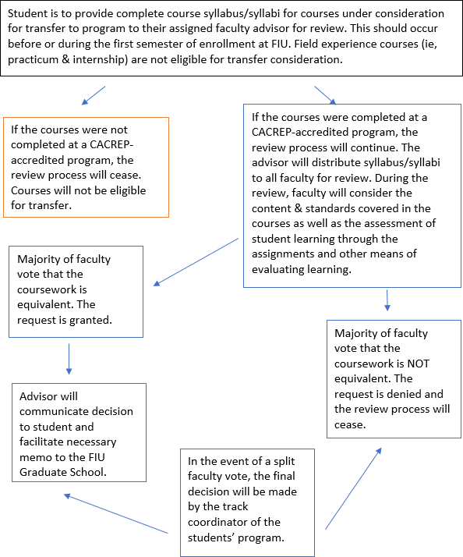

Time to Degree Policy
The Counselor Education program faculty follows the University Graduate School policy that all courses counted toward the Masters in Counselor Education must be completed within six years of first enrollment in the Masters program. Students readmitted into the program must retake courses that will be beyond the 6-year limit at graduation. No exceptions to graduation requirements will be submitted to the University Graduate School for courses beyond the 6-year limit at time of graduation.

Annual Review of Student Progress
Given the unique nature of the field of counseling, requiring mastery of cognitive skills and demonstration of relevant and appropriate interpersonal skills, the faculty retains the right to ‘counsel out’ of the program and/or not recommend for internship placement any student whose level of interpersonal competence is considered incompatible with that required for effective functioning as a counseling practitioner. Students may be identified during the annual student review or at any time during the program.
In addition to evaluation techniques utilized in courses (i.e. exams, papers, presentations), the Counselor Education faculty review the progress of every student enrolled in the program. At any faculty meeting, faculty can bring forward issues of concern related to students to determine if further supports are necessary. Every student is also evaluated each year. At the end of the fall semester, the faculty convene to discuss the progress of all Clinical Mental Health Counseling students; all students in the School Counseling and Rehabilitation Counseling tracks are reviewed at the end of the spring semester. The faculty’s perception of the student’s progress is documented on the Review of Student Progress Form (See Appendices). Each faculty member contributes input based on the student’s academic performance, personal and professional behavior in class, ability to get along with peers, openness to feedback and constructive criticism, as well as other aspects of their functioning as future counselor.

This information is recorded on the Student Progress Form and placed in the student’s academic file (electronic). The student’s progress will be discussed with him or her during the next scheduled advising session. If the student displays poor academic performance, inappropriate behavior or behavior not becoming of a professional counselor, an action plan is developed. His or her faculty advisor will notify the student and the action plan is then discussed with the student. The faculty reserves the right to monitor any student’s progress at any time during their enrollment in the program and to discuss problematic students on a continuous basis.
When a student is identified, the following process is followed:

- Student meets with the Advisor to discuss issues, concerns, and/or inappropriate behaviors identified by faculty.
- The student and Advisor meet with the Chair of the Department and Program Director to discuss the problem.
- A plan for remediation, if warranted, is developed for the student with a specific timeline for completion. At the end of the timeline, the student’s plan and behavior is re-evaluated.
- At that point, a decision is made regarding the disposition of the student and whether to allow the student to 1) continue the program, 2) withdraw, or 3) seek admission into an alternative discipline.

Advisement
Once admitted to the Counselor Education program, students are assigned to one of the faculty as their advisor. This information is included in the admissions acceptance letter. If a student does not know their advisor, one should inquire from the Program Director. It is expected that all students enrolled in the Counselor Education programs will meet or check in via email at least once a semester with their faculty advisor to review courses being offered and the progress toward their program of study, as well as receive support regarding professional issues. Additionally, at these meetings, the Panther Degree Audit on MYFIU will be reviewed with the student. It is the responsibility of the student to schedule these advisement meetings, keep track of their program of studies, and to follow the sequence of courses if they are in a cohort group.

Endorsement Policy
The Clinical Coordinator provides all counseling students who complete their practicum and internship hours with a letter of endorsement verifying location, hours, and clinical experience. This letter is to be submitted, along with the application, to the certification and/or licensure agency for which the student is seeking credentialing. For employment, students are advised to seek recommendation letters from faculty members who have had them for multiple courses or are in the best position to comment on their competence, clinical training, and potential for future employment or advanced study. Faculty may only recommend a student for a given area of employment if the student has successfully completed all designated curriculum requirements for the area for which the student is applying. This includes the completion of the required field experiences in each area of specialization. For example, a student applying for a school counselor position would need to fulfill all program requirements in order to be recommended by a faculty member for a position in this area. In addition to direct experience with the graduate student, faculty members will consider input from practicum supervisors when making recommendations. Regarding letters of support, for continued advanced study, faculty members take into consideration the student's demonstrated abilities and potential to successfully engage in research and scholarly writing. Our endorsement policy aligns with the 2014 ACA Code of Ethics. Before we endorse current students and/or alumni for future employment or advanced education,
faculty members ensure that an individual possesses the appropriate training, clinical experience, and competence with a review of one’s transcript.
Academic Warning, Probation, & Dismissal
Warning: A graduate student whose cumulative GPA falls below a 3.0 (graduate) will be placed on warning, indicating academic or other difficulty.
Probation: A graduate student on warning whose cumulative GPA falls below a 3.0 (graduate) will be placed on probation, indicating serious academic difficulty. The College/School of the student on probation may indicate conditions, which must be met to continue enrollment.

Students placed on academic warning or probation should immediately schedule a meeting with their program advisor to discuss course enrollment for the following academic semester.

Academic Dismissal: A graduate student on probation with a cumulative and semester GPA that falls below a 3.0 will be automatically dismissed from the program and the University. A graduate student will not be dismissed prior to attempting a minimum of 12 hours of coursework as a graduate student. The student has ten working days to appeal the dismissal decision. The appeal must be made in writing to the Dean of the College or the School in which the student is admitted. The dismissal from the University is for a minimum of one year. After one year, the student may reapply for re-admission (see re-admission) to the University in the same or a different program.

Non-Academic Dismissal: Consistent with the American Counseling Association and Florida International University policy, faculty are responsible to ensure that students are able to be ethical and personally effective. Concerns that may prohibit a student’s success in the field arising from candidate dispositions or behaviors are not considered confidential and may be discussed among faculty members and administrators. If concerns arise:

- The professor, advisor or candidate may request a meeting at any time in order to address the concerns. At this informal stage the advisor or the professor, and the student will review the concerns and discuss possible solutions to enact;
- If the concerns are not resolved informally or if a formal consideration is warranted without an informal attempt to a solution, a written referral is made to the Chair of the Department, who determines if a Candidate Concerns Committee should consider the concern. The Candidate Concerns Committee reviews the concern and develops a Remediation Plan. In some situations, a Remediation Plan may require personal counseling as a condition for continued enrollment
- Failure to meet the conditions of the Remediation Plan will result in a review by the Chairperson who may dismiss the candidate or revise/re-establish the remediation plan. The Department Chairperson may also dismiss a candidate from the program for a single egregious breach of professional and/or ethical behavior.
- Throughout the advisement process and up to dismissal from the program, the student is able to explore educational and career alternatives with the program advisor.

Academic Appeals/Student Grievance Procedures
Preamble: Students have the right to bring grievances against a faculty member or an administrator concerning academic matters. Such matters may include but are not limited to: failure to abide by the state policies and procedures articulated in a syllabus, unprofessional classroom practice, arbitrary and capricious awarding of grades, failure to respect a student’s right to privacy, and discrimination based on age, sex, religion, race, marital status, national origin, or disability. The EOP Office, following procedures developed in compliance with the Florida Equity Act, will handle the last category, discrimination. This document outlines the procedures by which student grievances are to be handled. It is designed as a University wide policy to replace the various individual unit policies and the “Student Grievance Procedure” outlined in the University Student Handbook. This policy will be in effect as of April 1, 1992. The student Government Council has an Advisory Branch to counsel and assist students in grievance procedures decisions. Students may contact the SGA office for more information.

Application for Graduation
Students who plan to graduate must submit to the Office of the Registrar an Application for Graduation form. This form is completed online and should be submitted before the last day of classes of the academic semester prior to graduation. Application deadlines can be found by referring to the Academic Calendar on the Registrar’s homepage. Students turning in the Application for Graduation after the deadline will graduate the following semester. There is no charge for applying for graduation. You must also apply online for the Commencement ceremony if you plan to participate.

Students must be enrolled for at least one semester hour the semester that they intend to graduate. Students who do not graduate must re-apply for graduation and complete the remaining requirements needed for graduation. The application can be found on the registrar’s office website.

Professional Organizations

National
Students are encouraged to join a variety of professional organizations that promote the interests of counselors. Faculty in the department are also actively involved members of these groups. Membership applications can be obtained directly from the organization or from faculty.

American Counseling Association www.counseling.org 1-800-347-6647
For more than 50 years, the ACA has been dedicated to the enhancement and growth of the counseling profession. It provides members with training opportunities, advocacy services, publications (to include The Journal of Counseling and Development and Counseling Today) and annual conferences. Students may also obtain professional liability insurance (student coverage) from the ACA. (Such insurance is mandatory for students who are going on practicum and internship experiences).

American Mental Health Counselors Association www.amhca.org 1-800-326-2642
The American Mental Health Counselors Association (AMHCA) is the professional membership organization that represents the mental health counseling profession. Clinical membership in AMHCA requires a master's degree in counseling or a closely related mental health field and adherence to AMHCA's National Standards for Clinical Practice. AMHCA provides members with a monthly newsletter (The Advocate) and a peer-reviewed journal (the Journal of Mental Health Counseling).

American School Counselor Association www.schoolcounselor.org 703-683-ASCA
asca@schoolcounselor.org
ASCA represents the needs of children and adolescents and our nation’s school counselors. They publish the peer-reviewed journal, the Professional School Counselor and the magazine, School Counselor. ASCA provides an annual conference.

American Rehabilitation Counseling Association www.arcaweb.org
The American Rehabilitation Counseling Association (ARCA), a division of ACA is an organization comprised of rehabilitation practitioners, educators, and students whose mission is to enhance the development of people with disabilities throughout their life span and to promote excellence in the rehabilitation counseling profession.

The National Rehabilitation Association www.nationalrehab.org 703-836-0850
membership@nationalrehab.org
The National Rehabilitation Association (NRA) began its commitment to persons with disabilities shortly after Congress passed the National Rehabilitation Act of 1920. It is the oldest and strongest advocate for the rights of persons with disabilities with the mission of providing advocacy, awareness and career advancement for professionals in the fields of rehabilitation. The National Rehabilitation Counseling Association www.nationalrehab.org is a division of the National Rehabilitation Association.
Chi Sigma Iota www.csi-net.org 336-841-8180
info@csi-net.org

CSI is the International Counseling Academic and Professional Honor Society. Delta Iota, FIU’s active local chapter, encourages students to become active members through serving as both board and committee members. This provides students with the experience of professional involvement. The Delta Iota Chapter sponsors many professional development activities for students and faculty including the New Student Orientation every fall semester, the Annual Installation of Officers and Initiation Ceremony, and various altruistic projects in the community. Students must be admitted into the counseling program, have completed 9 credits and have a graduate grade point average of 3.5 or higher to join.

State/Local
Florida Counseling Association www.flacounseling.org 407-628-0793
fcaoffice@flacounseling.org
A branch of the ACA, the FCA is committed to enhancing human development throughout the life span through the counseling profession. Membership benefits include annual conventions, professional development institutes, informative newsletters, volunteer activities, and awards and recognitions.
Students are encouraged to attend the annual convention.

Florida School Counselor Association www.fla-schoolcounselor.org/
A branch of the American School Counselor Association, FSCA expands the image and influence of school counselors in the state of Florida. FSCA empowers school counselors with the knowledge, skills, connections, and resources to promote equity, access to high-quality education and overall student success in school. The vision of FSCA is to represent all school counselors and promote the implementation of a comprehensive school counseling program in every Florida school.

Dade School Counseling Association www.dadecounseling.org dadeschoolcounselor@gmail.com

DCA is the local chapter of FSCA for Miami-Dade County. Students are encouraged to join the local chapter as a stepping-stone to joining the state and national organizations

Counselor Education Program Course Descriptions
EDF 6211: Psychological Foundations of Education (3). An intermediate course designed to apply theories and principles of learning and development to teaching and student learning in career areas related to education. Challenges of diversity and teacher effectiveness are emphasized.
EDP 6277: Human Development: Across the Life Span (3). Advanced survey of life span human development. Demographic, physiological, sociological and psychological factors contributing to optimal functioning from infancy through adulthood and aging. Applications to counseling and education.
MHS 5340: Educational and Vocational Counseling (3). Concepts and skills pertaining to vocational development, information systems, career education programs, educational-vocational counseling, and socio-psychological influences on career development. Prerequisites: MHS 5400.
MHS 5400: Counseling Skills and Techniques (3). Major theoretical concepts in counseling, competencies in relationship building, interviewing, role-playing, simulation, and micro counseling.
MHS 6020: Foundations of Mental Health (3). This course provides an examination of the significant events in the history of mental health care that has contributed to the development of the specialty within the counseling profession. Prerequisite: MHS 5400.
MHS 6200: Measurement and Appraisal in Counseling (3). Concepts and skills related to the use of tests and other appraisal procedures in counseling. Particular emphasis on career and vocational choice processes. Laboratory experiences included. Prerequisites: EDF 5481 or MHS 6630.
MHS 6411: Counseling and Consultation in Community Settings (3). This is an advanced counseling and consultation course that examines general principles of community counseling, including, but not limited to, prevention, intervention, education, outreach, advocacy, consultation, crisis intervention, and service delivery in various community settings. Prerequisites: MHS 5400 and MHS 6700.
MHS 6427: Adult Psychopathology (3). The study of the causes, treatment, and diagnosis of emotional and behavioral disturbances in adults will be examined in this course. Prerequisites: MHS 5400.
MHS 6428: Cross Cultural Counseling (3). This course explores concepts and skills involved in counseling clients with backgrounds that are culturally and linguistically diverse. Prerequisites: MHS 5400.
MHS 6450: Substance Abuse Counseling (3). This course will educate mental health practitioners in understanding substances and techniques in counseling those who abuse them. Prerequisites: MHS 5400.
MHS 6470: Human Sexuality Counseling (3). Counseling issues, strategies, and resources in human sexuality relative to mental health professionals. Prerequisites: MHS 5400.
MHS 6511: Group Counseling (3). Exploration of roles and function of group counseling in meeting client needs in a variety of settings. Prerequisites: MHS 5400.
MHS 6630: Foundations of Educational Research (3). Competencies required for the design, implementation, and evaluation of educational research, including problem formulation and analysis; sample selection; instrument selection; formulation of research design and procedure; and data analysis.
MHS 6700: Ethical, Legal and Professional Issues in Counseling (3). Competencies in regard to the development of major role and service models and the application of budgeting systems, legal, and ethical standards in psycho-educational settings.
MHS 6800: Advanced Practicum in Counseling (3). Advanced competencies in counseling and consultation. Prerequisites: Course work completion or faculty approval.
MHS 6802: Personality Theories (3). A survey of the various cognitive, psychodynamic, behavioral, humanistic, existential and family systems theory of personality development of change are examined.
MHS 6820: Supervised Field Experience in Counseling (9). Demonstration of the full range of competencies learned throughout the program in counseling. Internship placements include a variety of field settings. Prerequisites: MHS 6800 and course work completion.
RCS 6031: Rehabilitation Counseling: Principles and Practices (3). A survey course that provides an orientation to the rehabilitation process including the history, principles, philosophy, and legal aspects of rehabilitation counseling and related field.
RCS 6080: Medical Aspects of Disability (3). Course surveys medical etiology and elements of knowledge useful in the assessment, management and rehabilitation of individuals with disabilities or chronic illnesses.
RCS 6245: Psychological/Sociological Aspects of Disability (3). Psychological/sociological aspects of disability in relation to socio/political forces, attitudes, and behaviors that impede or facilitate the options of individuals with disabilities in schools and communities.
RCS 6625: Service Delivery and Case Management in Rehabilitation Counseling (3). This course is an evaluation of the laws, policies, and social factors that influenced the roles and function of rehabilitation counselors in the vocational rehabilitation process.
RCS 6801: Advanced Practicum in Counseling (3). Advanced competencies in counseling and consultation. Prerequisites: Course work completion.
RCS 6821: Supervised Field Experience in Counseling (9). Demonstration of the full range of competencies learned throughout the program in counseling. Internship placements include a variety of field settings. Prerequisites: RCS 6801 and course work completion.
SDS 5420: Counseling Students with Exceptionalities (3). An overview of the academic, personal, social and career needs of students with physical and emotional disabilities and counseling implications and strategies for working with special education students in school settings.
SDS 5460: Crisis Counseling and Interventions (3). Prevention and intervention strategies in crisis situations including child abuse and neglect, suicide, substance abuse, AIDS, and personal loss. Pre- requisite: MHS 5400.
SDS 6411: Counseling Children and Adolescents (3). Theory and application of counseling elementary age children and adolescents including family issues and interventions, legal and ethical considerations and counseling at-risk and exceptional children. Pre-requisite: MHS 5400.
SDS 6700: Organization and Administration of School Counseling (3). Components, elements and interventions of comprehensive, developmental school guidance program models. Emphasis on organization, administration, and evaluation of system, components, and services.
SDS 6800: Advanced Practicum in Counseling (3). Advanced competencies in counseling and consultation. Prerequisites: Course work completion.
SDS 6820: Supervised Field Experience in Counselor Education (9). Demonstration of the full range of competencies learned throughout the program in counseling. Internship placements include a variety of field settings. Prerequisites: SDS 6800 and course work completion.
SPS 6199: Family-School Consultation and Collaboration (3). Designed to develop essential communicative/interactive interpersonal skills, as well as collaborative problem-solving skills, in special education, counseling, and school psychology graduate students.

Appendices
- Annual Student Evaluation Form
- Accreditation and Training Standards
- Florida DOE
- FEAPS
- CACREP
- CORE

Appendix A: Annual Student Evaluation Form

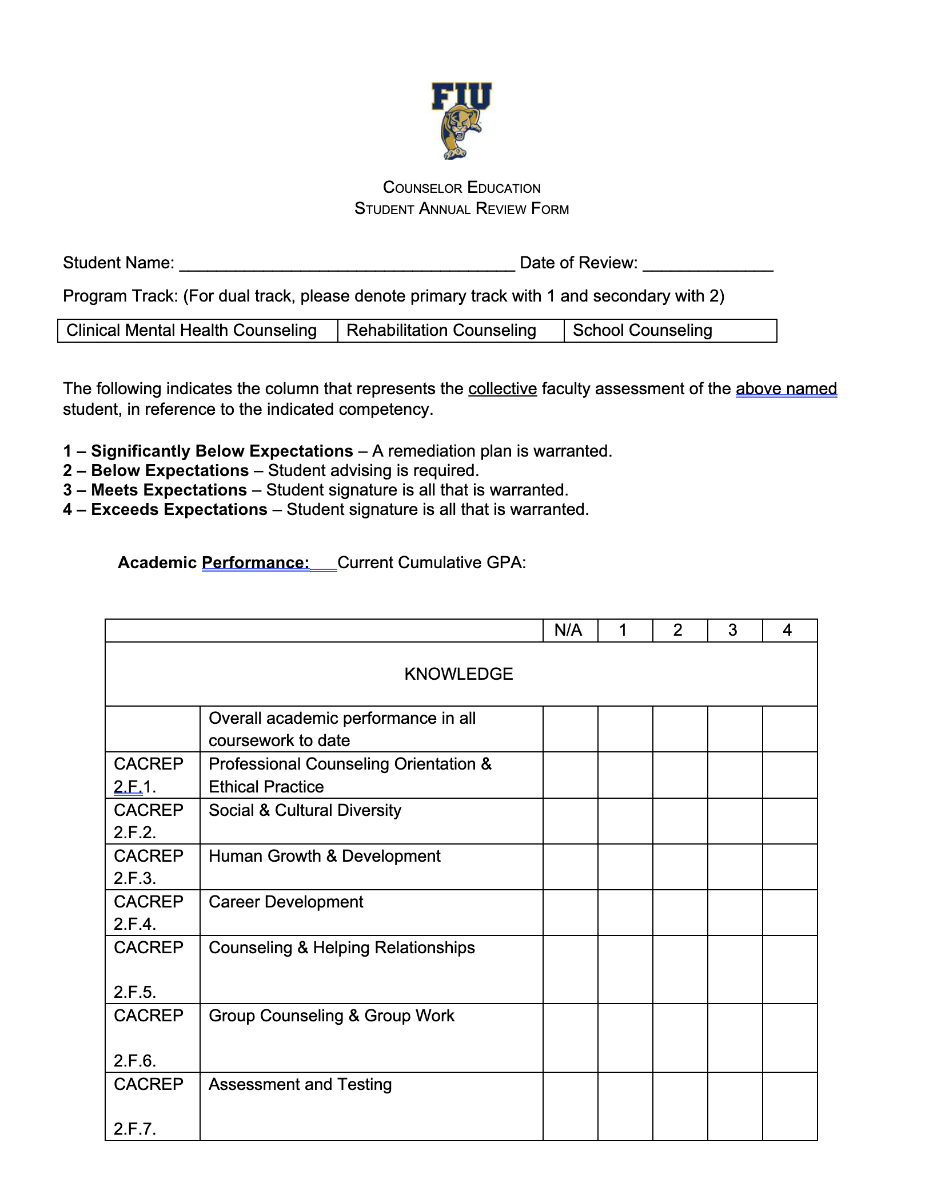
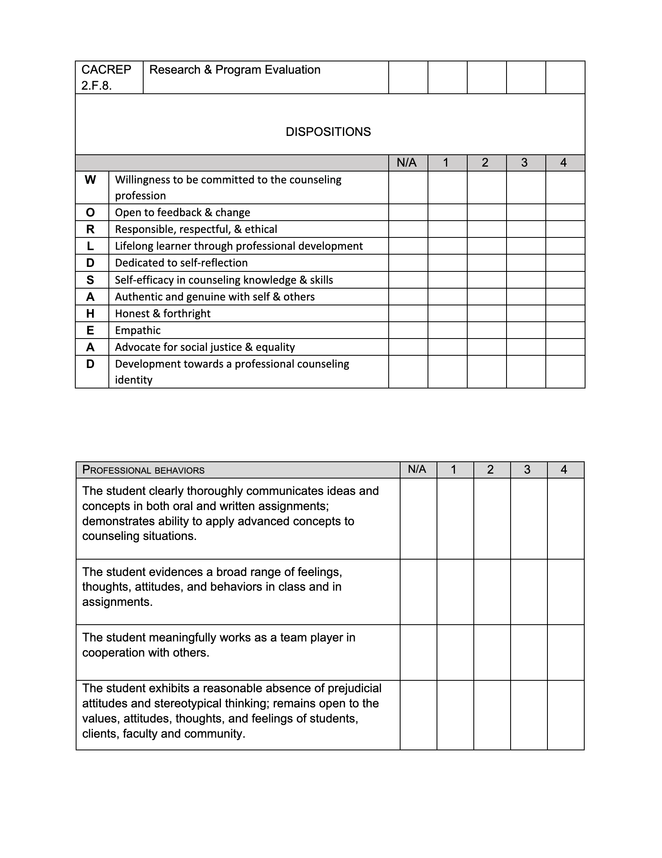
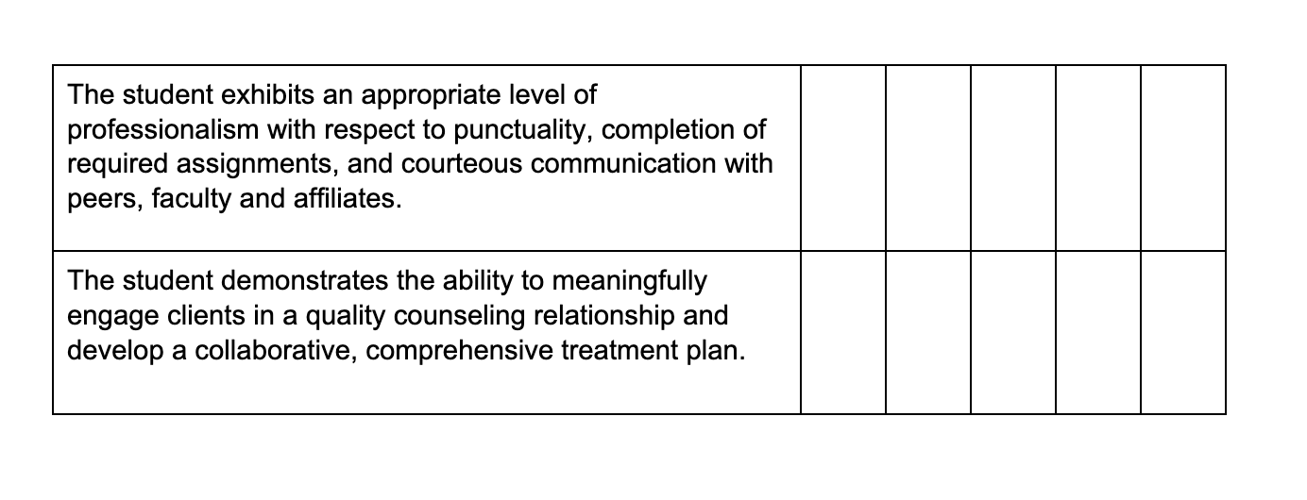
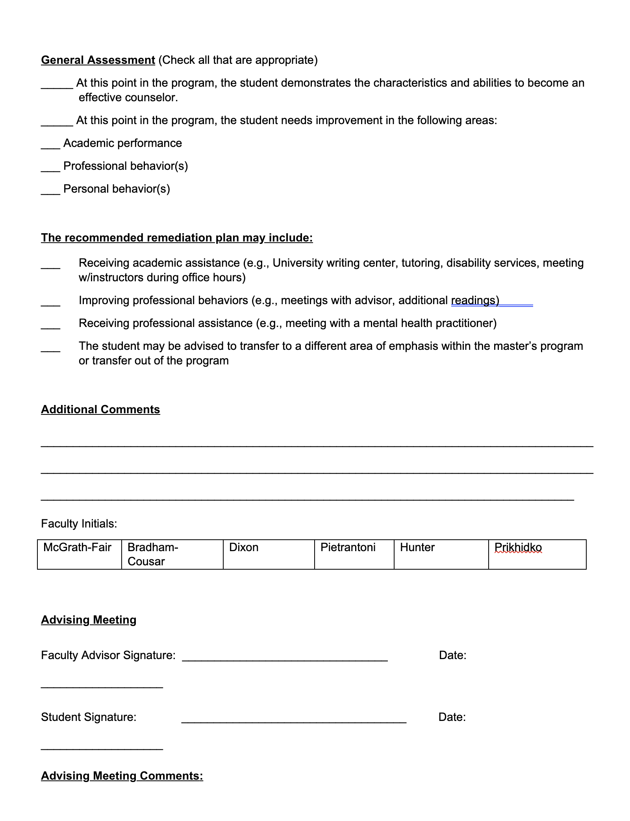

Appendix B: Accreditation & Training Standards
FLDOE Competencies & Skills: Counseling & Guidance
Use this link to access the most recent version (24th edition).

Florida Educator Accomplished Practices (FEAPs)
Use this link to access the most recent version.

Council for Accreditation of Counseling & Related Educational Programs (CACREP)
Use this link to access the most recent version.

Council on Rehabilitation Education (CORE)
Use this link to access all CORE accreditation standards.

Counselor Education Student Handbook Acknowledgement
Please complete the Handbook Acknowledgement Survey to confirm that you have read and understand the Counselor Education Program and Florida International University’s policies.

